Safe Organization

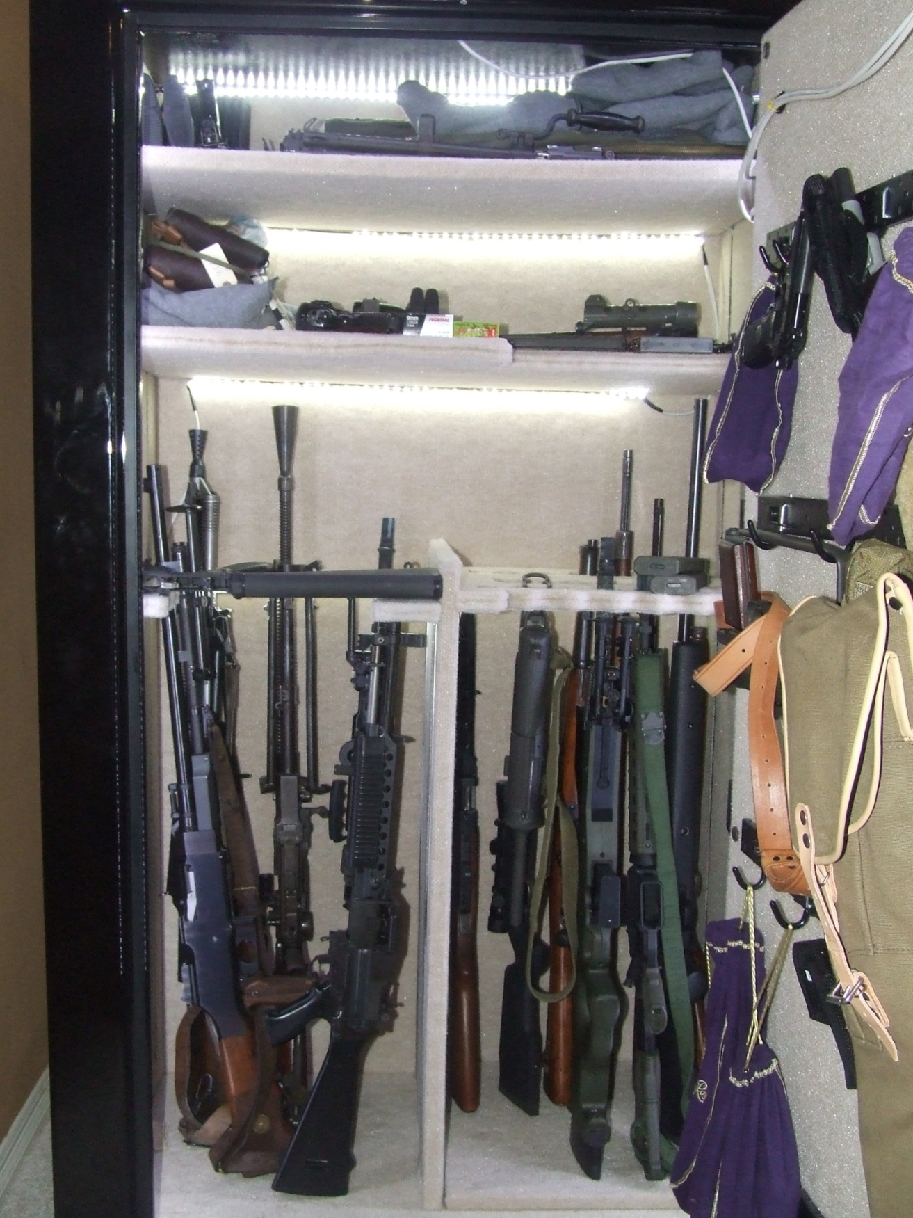

Pictures of one of my safes from 10 years ago (before it got full)

## The Safe is Full Again!

Basic laws of physics dictate a gas will expand to fill the volume it is in. The gun world equivalent is the number of guns will increase to fill the gun safe no matter how big of safe you bought. This typically will cause your wallet to merge with your safe and generate another safe to start the process over. Unfortunately I am at the point of not wanting to buy another safe nor do I really have the room for one.

## Time for Plan B

Suggestions from various sources on the internet were recommending “Rifle Rods” to increase the number of guns you can story in your safe. Those not familiar with Rifle Rods, they are plastic rods slightly smaller than 0.22” (5.5mm) in diameter with a flat end pad with Velcro on it for sticking to the underside of the shelf above the gun. The safe must have some sort of Velcro receptive covering on the bottom of the shelf for the Rifle Rod to stick to it. The typical gun safe carpet lining seems to have great affinity for Velcro so it works well. The Rifle Rod company does sell a fabric you can mount on the bottom of the shelf above the rifles if your safe does not have a suitable cheesy carpet. I purchased enough of them from Amazon to use on the long guns in the safe I was having issues with. I chose the orange colored ones, black being the alternate color, to ensure that they were easier to see in a bore. The last thing I want is an expensive machine gun to blow up due to an unnoticed Rifle Rod in the bore. The guns in the safe ranged from the longest, a Japanese Type 99 LMG, down to the shortest, a M3A1 Grease Gun. Several guns in the safe are LMGs and are heavier than your average hunting rifle.

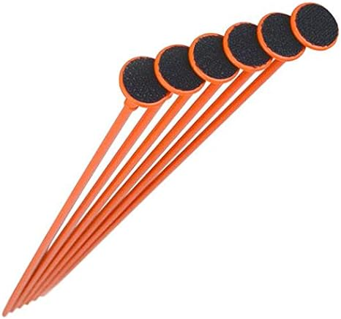

Picture of typical “Rifle Rods” as sold by Amazon

We started by removing all the guns and the dividers from the safe. I had one side with an easy out interior divider and the other side was a multi row divider that was designed by some asshole that hated optics and never wanted you to get any gun out past the first row. Immediately we noticed that the shorter guns, as anything with more than 3” (76mm) of Rifle Rob sticking out of the bore would flex the rod. The height of the shelf above the rifles was dictated by the longest gun to be stored. The 20” (508mm) M16s, though being very light, flexed the Rifle Rods considerably unless the gun was perfectly balanced. There was no hope for the submachine guns since the Rifle Rods would not even reach to the barrels when the butts were on the floor. I considered placing a “milk” crate (yes, even as I near 60 I still have some milk crates from college) on the floor for the SMGs but this ate room and they were still very short. We just stacked the SMGs in the corners of the safe and went with it. This left me unhappy and thinking of ways to fix the issues. There was no doubt you gained room storing the guns in this manner but the flexing rods drove me crazy. The very heavy LMGs that were not as long as the Japanese Type 99 LMG were really testing the limits of the rod’s bending strength. Destructive devices with bores above 26mm were hopeless with the rods.

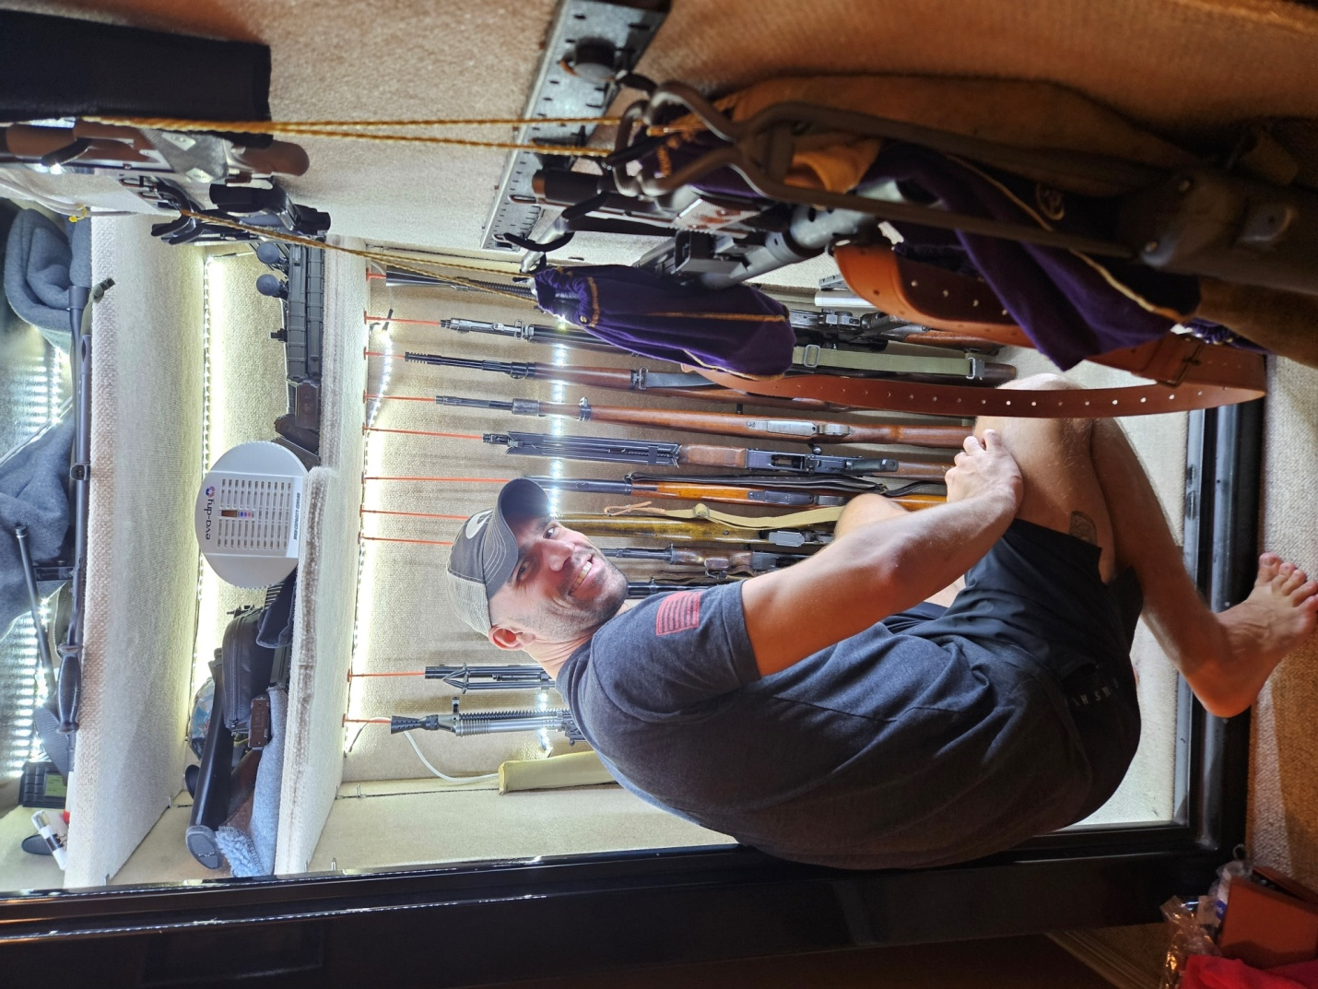

Picture Always recruit kids to help, James currently a Sergeant in the Army with his future gun collection

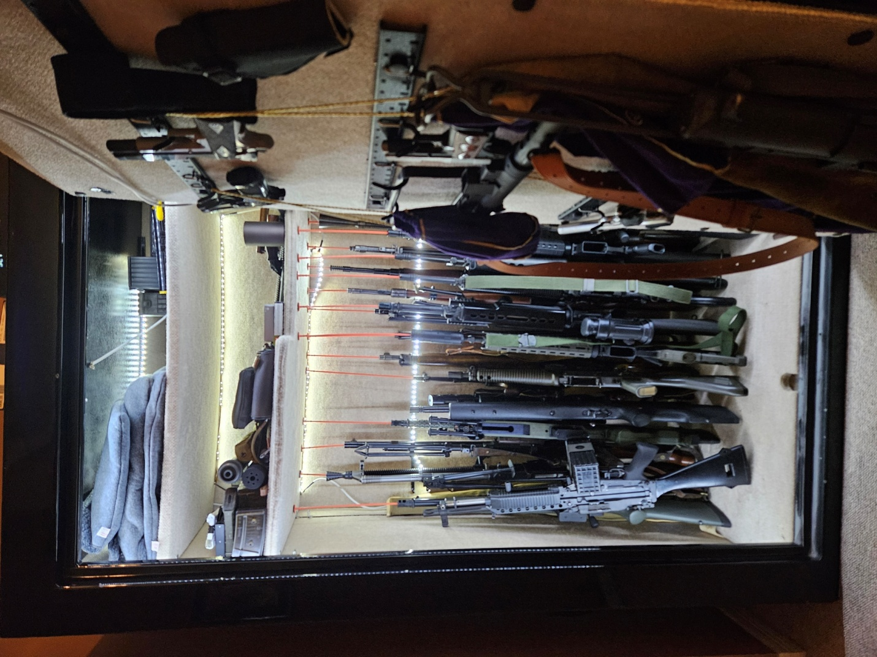

Picture of first reorganization with the Rifle Rods, already you can see the bending starting

## Plan C

I was starting to think about ways to fix the various issues that had cropped up. My first thought was to make new Rifle Rods with metallic tubing welded to a larger diameter metal flat head to make the system more ridged. Unfortunately cost would start adding up quickly. I was also to damn lazy to find someone to build the new rods based on my design. The new rod design would also require finding a suitable coating for the rods to keep them from having metal to metal contact in the bore possibly causing corrosion. Screw it, we are going to fix what we have and do it on the cheap.

Stiffening the rod was my first concern so I measured the diameter of the rods and decided 7mm brass tubing would slip over the rod. This would stiffen the rod but I would cut the tube short of the bore so there would be no bimetallic contact that could result in corrosion. This would mean that for each rifle length I would have a different length of brass tube to cut. I ordered a tubing cutter with the brass tubing from Amazon to get the job done for the mid to longer barrel guns. The brass tubes were crimped with pliers (I was going to hot glue them but could not find my hot glue gun) onto the plastic rod after the brass was cut to length.

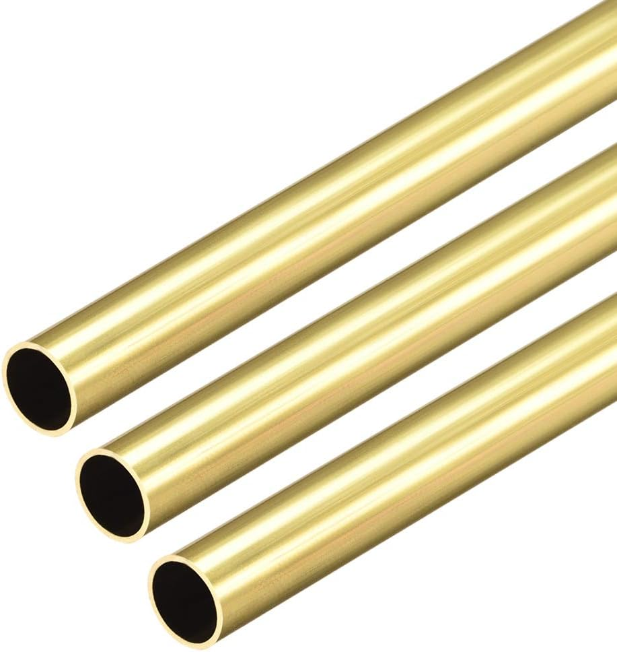

Picture 7mm brass tubing as sold by Amazon

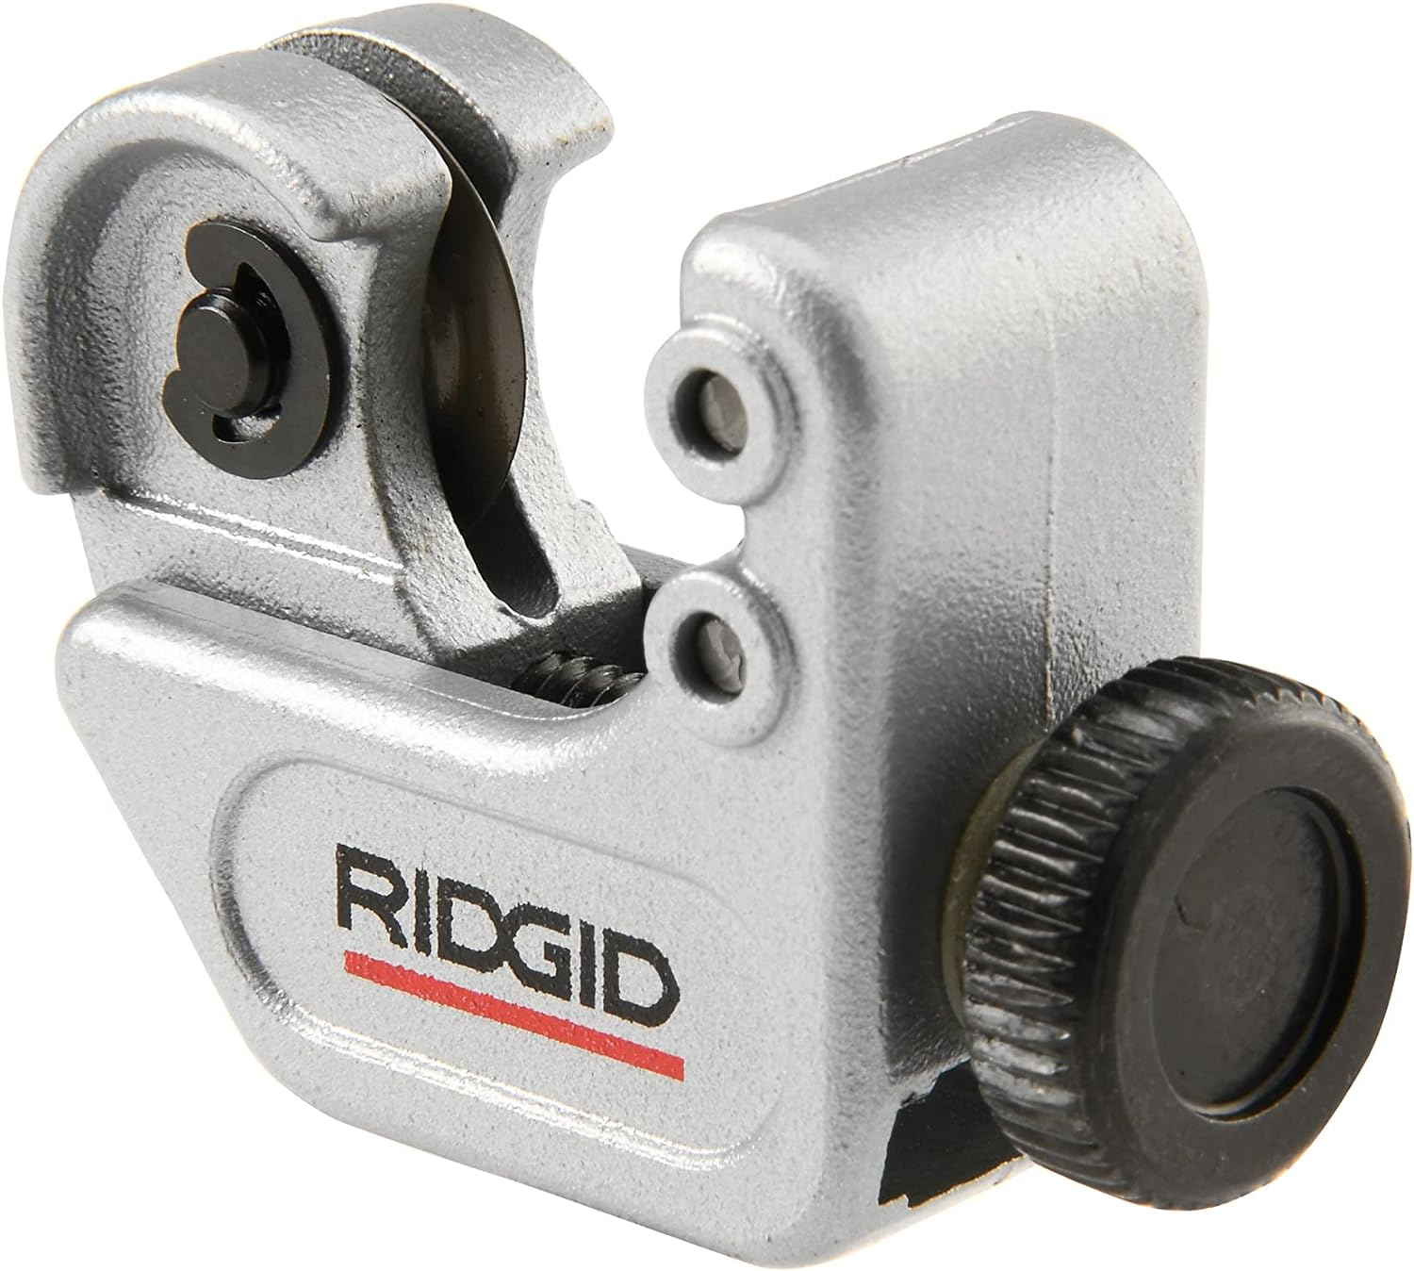

Picture tubing cutter bought from Amazon for the trimming job on the brass tubing

The SMGs and SBRs were still going to be an issue. Searching through Amazon presented a possible solution. There was a dense foam barrel spacing rack with a magnetic backing for placing in a safe. I bought one of these kits and applied Velcro in place of the magnetic strip since the carpet would not allow the magnet to stick to the side of the safe. This would allow me to place them closer to the bottom of the safe against the outer walls for the SMGs and SBRs.

Between the tubing and the foam dividers the storage issue seems to be resolved for now. Some of the SMGs I hung on the door hooks next to the few handguns I already had there. The SMGs with folding or collapsing wire stocks hang pretty well though SMGs like the Ppsh41 have to use the foam dividers.

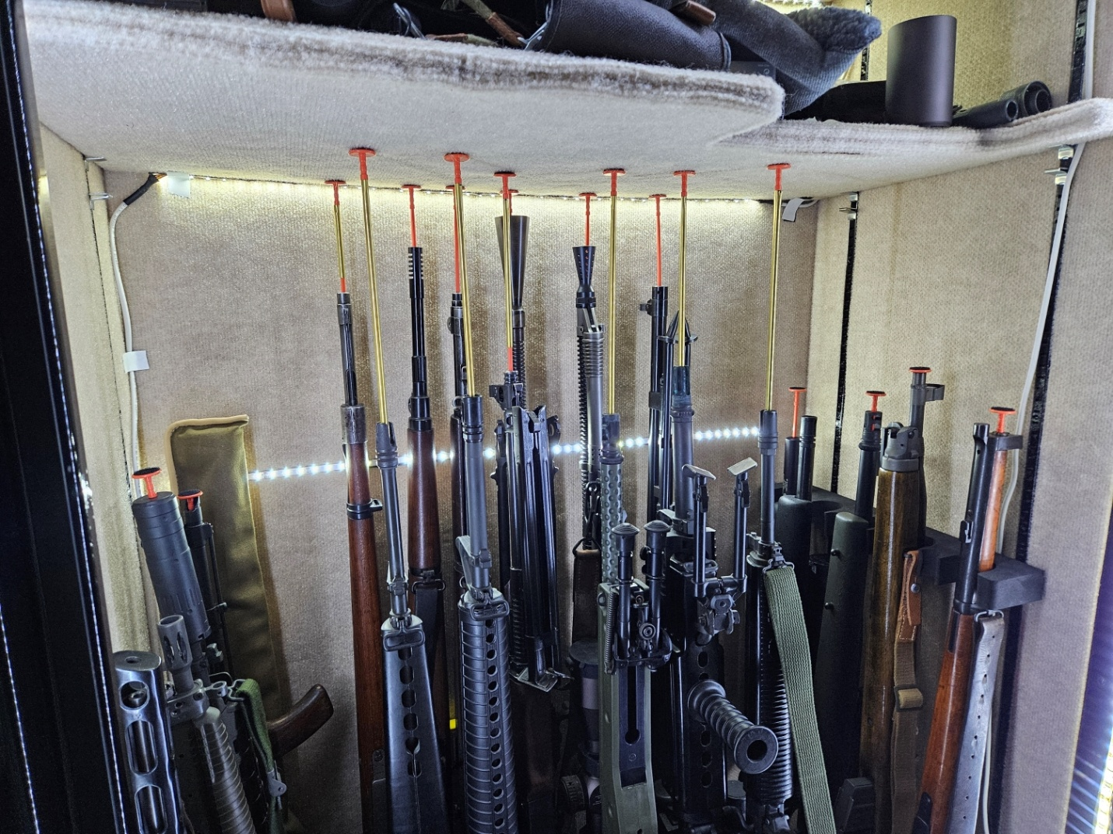

Picture final arrangement/solution with the shorter guns against the outer walls in the foam dividers

## Concerns and Parts List

I like to store some guns with rubber butt pads muzzle down. Over time the rubber butt pads can deform due to the weapon’s weight. This system does not allow that.

Parts List:

* Rifle Rods – [Amazon Link](https://www.amazon.com/dp/B06XKQZKVV?ref=ppx_yo2ov_dt_b_product_details&th=1)
* 7mm Tubing – [Amazon Link](https://www.amazon.com/dp/B07Z99NT1V?ref=ppx_yo2ov_dt_b_product_details&th=1)
* Tubing Cutter – [Amazon Link](https://www.amazon.com/dp/B000LDGNCU?ref=ppx_yo2ov_dt_b_product_details&th=1)
* Foam Dividers – [Amazon Link](https://www.amazon.com/dp/B0B46BTJF1?psc=1&ref=ppx_yo2ov_dt_b_product_details)
* Helper Kid – Got to make your own